AI-AUGMENTED BACKEND DEVELOPMENT AI BLOGNEST API
ROLE | TEAM MEMBER
TEAM LEADER | J. JANANI
TEAM MEMBER | G. KIRTHIKA
TEAM MEMBER | R. NANDHINI
TEAM MEMBER | V. NISHA
PHASE 4 – PROJECT PLANNING

1. Introduction
The Planning phase prepares the development environment and creates the basic backend project structure.

Development Environment
- Install Node.js and npm.
- Install Visual Studio Code or a similar editor.
- Set up MongoDB for database operations.
- Install Postman or Thunder Client for API testing.

Project Folder Setup
- Create the project folder.
- Create a Server folder for backend development.
- Open the project in VS Code.
- Initialize the Node.js project using npm init -y.
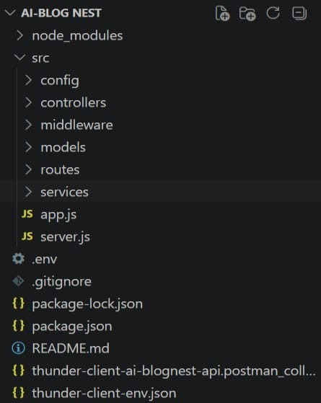

Basic Backend Structure
- server.js – starts the backend server.
- app.js – configures the Express application.
- models – contains database schemas and models.
- controllers – contains request-handling logic.
- routes – contains API route definitions.
- services – contains reusable business and AI logic.
AI BlogNest API | Phase 4 – Project Setup & Configuration

Dependencies
- Express.js for backend routing.
- Mongoose for MongoDB communication.
- Authentication and security packages as required.
- AI service package or API integration for intelligent features.

Configuration
Configure environment variables for database connections, server settings, authentication secrets and AI service credentials. Sensitive values should not be placed directly in source code.

Expected Outcome
A ready-to-develop backend environment with an organized project structure is created. 8. Conclusion
This phase establishes the development foundation required for backend implementation.
AI BlogNest API | Phase 4 – Project Setup & Configuration

